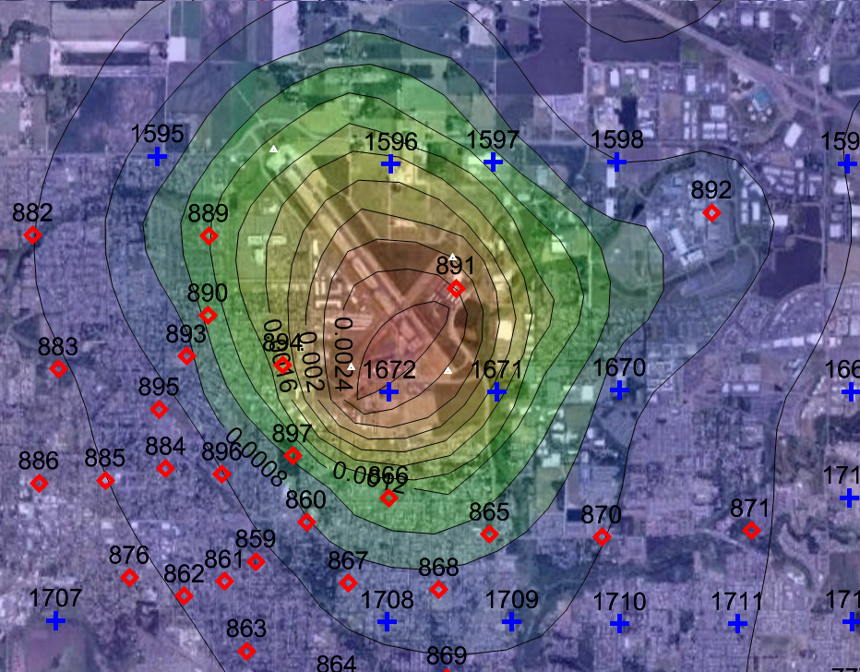
Hillsboro Airport PATS 2017 Lead concentrations using stacked elevated volume sources and CALPUFF. (12/15/2010 PhA)

